Unit 4 Producing Plots and Introduction to Calculus

The Learning Outcomes-
- Discuss the different types of graphs and plots
- Explore the basic plot functions in R
- Illustrate adjusting the axes, colour and size of a plot in R
- Explore plots in Python
- Explore differential and integral calculus in R

-------------------------------------------------------------------------------------------------------------------------------------

Graphs and Plots
Creating bar charts, histograms, pie charts, boxplots and scatter plots for different types of data
Creating data visualisations to examine the association between data
Graphical representation of data gives a broader and deeper understanding of patterns in the data. The main idea of generating and presenting graphs is to organise the raw data to present the pattern in a concise way for better understanding. Generally, it depends on the nature of the data.
In this unit, the following charts /graphs are covered-
- Bar Chart
- Histogram
- Pie chart
- Scatter plot
- Boxplot
- Line graph

Graphs and charts are often used interchangeably, although there is a basic difference between them. Graphs are created using raw data and show the trend, for example, line graph. On the other hand, charts are usually based on classified, categorised and summarised data, for example, bar chart.

Packages in R
We need to have a Graphics package installed in R before starting this unit.

Dataset
In this unit, we will be using Crime Survey for England and Wales, 2013-2014: Unrestricted Access Teaching Dataset from this link and download and save the SPSS sav.version. Save the data into a folder that you would like to save your analysis.

Bar Chart
Bar charts are a common way to graphically display the data that represent the frequency of each level of data. They can be used to illustrate the relative frequency of levels of a data by graphically displaying the number r of cases at each level of the data.
We can create the bar charts in R using barplot () function. The following bar chart shows the number of observations for the walkdark.
Use the following command:
barplot(table(csew1314teachingopen$walkdark))
This will produce the following graph
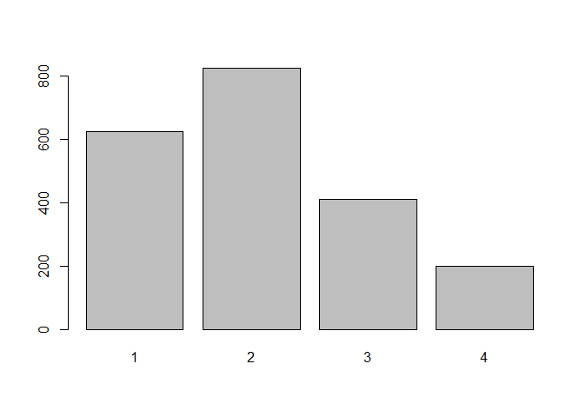Removing missing values
By looking at the dataset, we can find that there are so many missing values and also have categories such as ‘Refusal’ and ‘Don’t Know’ with a count of 0, which add noting to the analysis. We can remove them using the following command:
> count <-table(csew1314teachingopen$walkdark,useNA = "no")
> barplot(count)
Note that, ‘useNA’= “no” would have removed the ‘Refusal’ and ‘Don’t Know’ categories in this example.

Adding a title and colour
To add a title to a bar plot, use the following code:
> barplot(count, main = "How Safe respondents feel when walking alone after dark")
Make the bar plot more appealing and colourful, use the following code:
> barplot(count, main = "How safe respondents feel when walking alone after dark",col="darkblue")
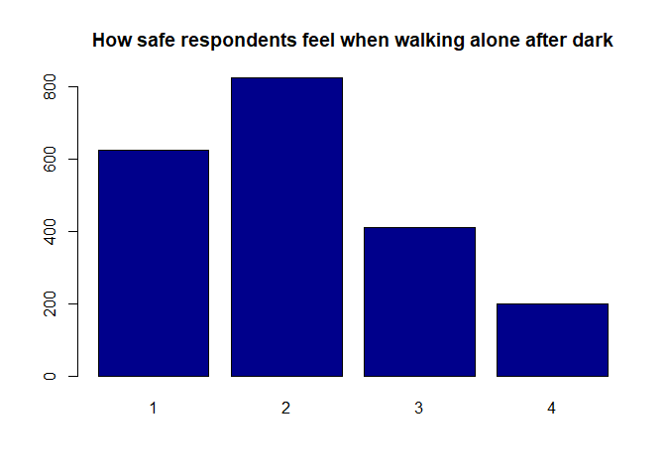

Histogram
Histograms look similar to bar charts, but the purpose of the histograms is quite different. A histogram is used along with the normal distribution curve to examine the normality in the data. Here, normality refers to the distribution of data that has equal data values on both sides of the mean value.
Histograms are created using hist() function, use the following command:
hist(csew1314teachingopen$worryx)
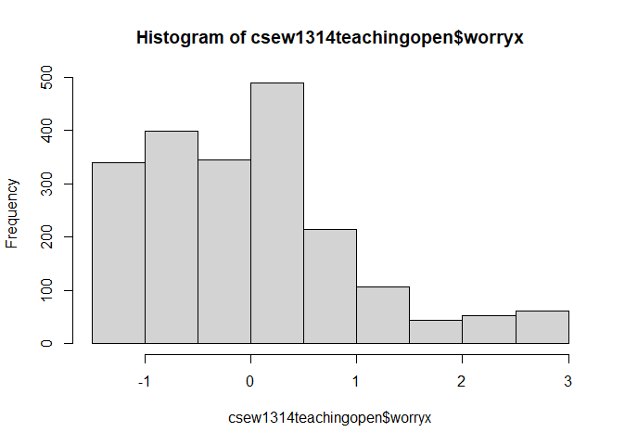
You can see that the histogram gives you the insight into the minimum, maximum values, median and skewness in the data. Skewness is the measure of asymmetry and can reveal information about outliers. The above histogram shows that it is positively or rightly skewed, meaning that most of the values are grouped around the left tail of the distribution.

Adjusting the size of the bins
The parameter ‘breaks’ in R allows you to adjust the size of the bins in the histogram. You can set specific value for the number of breaks to make the graph more understandable. For the following example, we used 20 ’breaks’.
hist(csew1314teachingopen$worryx,breaks = 20)
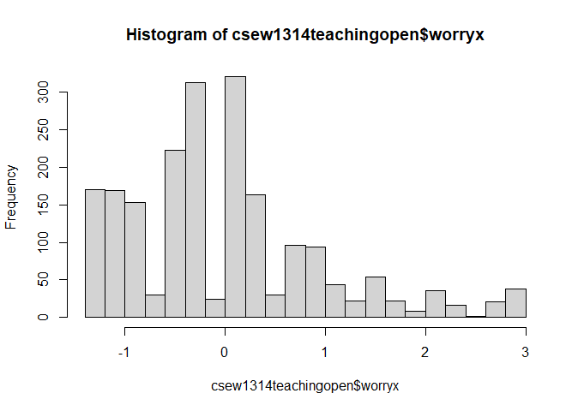

Adding title and labelling the x-axis
In addition to the breaks parameter, you can change the default title and the name of the x-axis by adding the main and xlab parameters to the hist function. For example,
hist(csew1314teachingopen$worryx, main="Worry about being victim of crime using 30 breaks", xlab = "level of worry about being victim", breaks=30)
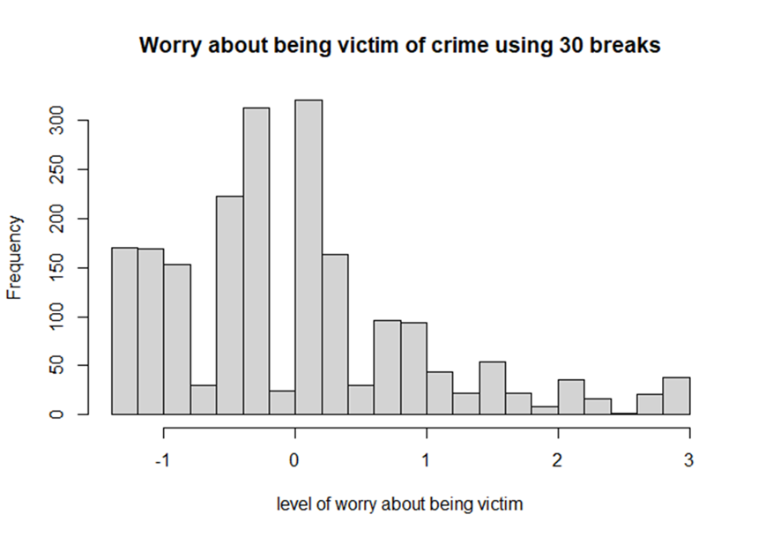

Pie Chart
Pie charts are used to graphically display percentages of cases in each category of a variable. They can be used to illustrate the relative percentages of levels of a variable by graphically displaying the percentage of total cases at each level of the variable.
R has built in datasets that are automatically installed onto your computer when you download R and R Studio. To form a pie chart using R, we will use preinstalled R dataset ‘mtcars’
To use the dataset, try the following code-
> data("mtcars")
Now using the above dataset, we are interested in getting the idea about relative proportions of cars on the basis of cylinders. This can be done by displaying the percentages of cars, classified by number of cylinders in a pie chart. So, it is required that to extract the frequencies of cars each category such as – cars with four cylinders, six cylinders and eight cylinders.
Frequencies can be extracted using the following command:
> propcyl<-table(mtcars$cyl)
Now, the pie chart can be generated using the following command:
pie(propcyl)

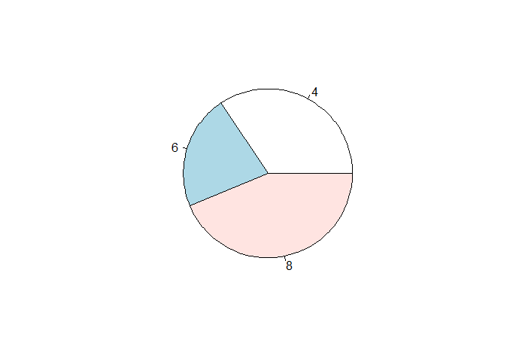

Scatter Plot
Scatter plots generally examine the relationship between two variables. Before running the correlations between two variables, it is recommended to examine the scatter plot. The scatter plot will reveal the nature of relationship between two variables.
Using the mtcars data, we can examine the relationship between weight of a car and miles per gallon.
The scatter plot can be generated by executing the following command:
plot(mtcars$wt, mtcars$mpg, main = "Scatter plot of weight versus mileage", xlab = "Weight (1000 lbs)", ylab = "miles per gallon")
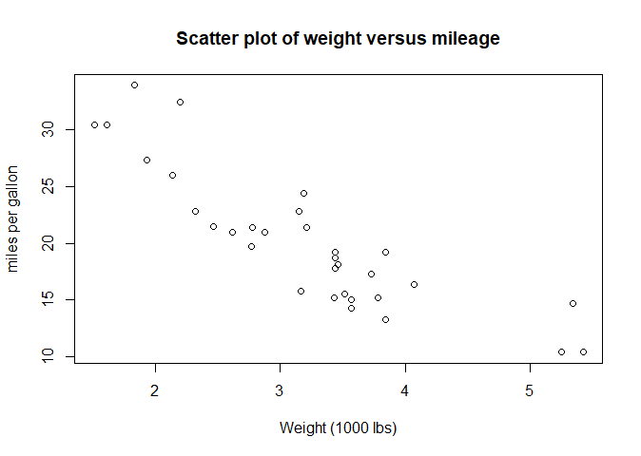Boxplot
Boxplot represents the data classified into four divisions, called quartiles. Each quartile represents 25% of data and the middle quartile is the same as median. The plot is also used to measure the normality and therefore the data requires to be measures on a continuous scale.
We will continue with the example of mtcars and use the following command:
boxplot(mtcars$mpg)
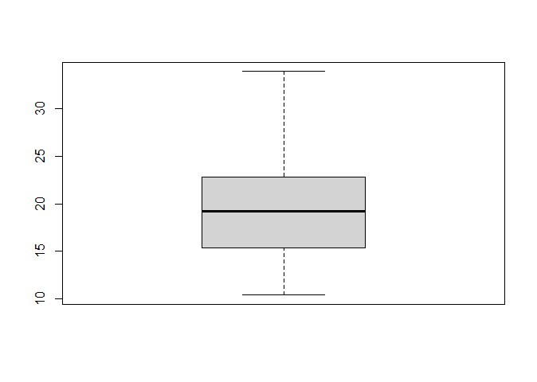The boxplot can be made more informative by adding a chart title and axes titles to it, using this command:
boxplot(mtcars$mpg, main= "Mileage per Gallon", ylab="Number of cars", col = "pink")
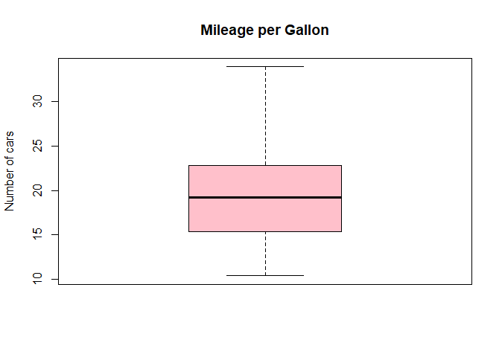

Line Graph
Line graphs use raw data and plot it against time. They are often misused to represent data that are not measured on a timeline. Line graphs are also used to show the pattern of changes over a period of time. Line graphs can be used with weekly, daily and high frequency data.
To perform the line chart in R, we will be using BOD dataset. This dataset contains two variables: Time and demand.
To get the dataset, type the following command:
>data(BOD)
Now to get the line graph, execute the following command:
plot(BOD$Time, BOD$demand, type = "o", main = "Line graph for Biochemical Oxygen Demand", xlab = "Time", ylab ="Demand (mg per litre of water)")

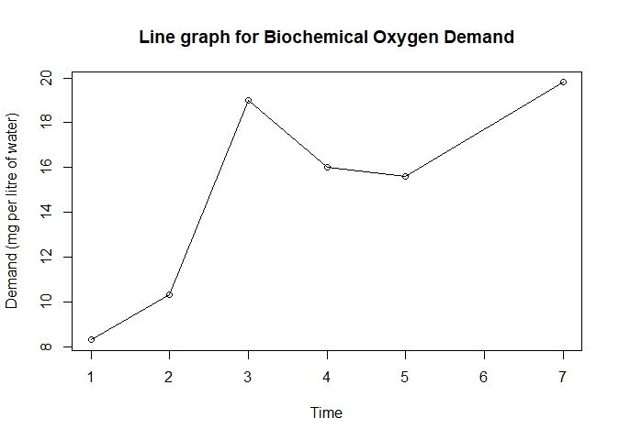

References:
Daniel, W.W. & Cross, C.L., (2018) Biostatistics: a foundation for analysis in the health sciences. Wiley.
Fox, J. (2005) Getting started with the R commander: a basic-statistics graphical user interface to R. J Stat Softw, 14(9):1-42.

Kulkarni D. K. (2016) Interpretation and display of research results. Indian journal of anaesthesia, 60(9): 657–661. https://doi.org/10.4103/0019-5049.190622

Python libraries

Plotly and Seaborn

Read through the word documents on these two activities:
- Data Visualisaton_plotly
- Data_Visualiation_Seaborn
which are linked to these two CSV data files, respectively:
- blood_pressure_plotly.csv
- titanic_modified_seaboard.csv
Then carry out the activities in the respective Jupyter Notebook files (also available in the Codio workspace).
- bloodpressure_plotly_Notebook.ipynb
- Titanic_Seaborn_Notebook.ipynb
You can also review the Python library, matlplotlib, via their webpage, which includes an interactive example and their tutorial.

Performing Calculus using R

Before performing differential and integral calculus in R​, you can download the “mosaic” package:
> install.packages("mosaic")​
You can then turn a mathematical expression into a corresponding R function using the makeFun command. Some examples and the corresponding outputs are shown below.
f <- makeFun(m * x + b ~ x, m = 3.5, b = 10)​
f(x = 2)​
17​
​
g <- makeFun(A * x * cos(pi * x * y) ~ x + y, A = 3)​
g​
function (x, y, A = 3)​
A * x * cos(pi * x * y)​
g(x = 1, y = 2)​
3​

An alternative to downloading the mosaic package is to use base R to do some basic calculus (see this video). Some examples are shown below and the corresponding outputs:

Derivative Functions in R​
D(expression(2*x^3),"x")​
2 * (3 * x^2)​
D(expression(log(x)),"x")​
1/x​
​D(expression(a*exp(-b * x)),"x")​
-(a * (exp(-b * x) * b))​

Integration Functions in R​ (finding the area under the curve)
integrate(dnorm,0,Inf)​
0.5 with absolute error < 4.7e-05​

​

integrate(dnorm,-Inf,Inf)​
1 with absolute error < 9.4e-05​

integrate(function(x) rep(2, length(x)), 0, 1)​
2 with absolute error < 2.2e-14​

integrand <-function(x) {1/((x+1)*sqrt(x))}​
integrate(integrand, lower = 0, upper = Inf)​
3.141593 with absolute error < 2.7e-05

